RAJALAKSHMI INSTITUTE OF TECHNOLOGY
(An Autonomous Institution, Affiliated to Anna University, Chennai)


DEPARTMENT OF ARTIFICIAL INTELLIGENCE AND DATA SCIENCE ACADEMIC YEAR 2025 - 2026
SEMESTER IV

AD23411 – DATA ANALYTICS LABORATORY MINI PROJECT REPORT

REGISTER NUMBER | 2117240070043
NAME | T.CHANAKYAN
PROJECT TITLE
DATE OF SUBMISSION
FACULTY IN-CHARGE

Signature of Faculty In-charge Signature of HoD

Internal Examiner External Examiner

INTRODUCTION

Traffic accidents are one of the leading causes of death and injury across the world. With the rapid increase in population, urbanization, and the number of vehicles on the road, managing road safety has become a major challenge for governments and authorities. Every year, millions of accidents occur due to various factors such as poor road conditions, unfavorable weather, human error, and traffic congestion.

In recent years, the availability of large volumes of accident-related data has opened new opportunities for analysis using data analytics techniques. Data Analytics plays a vital role in understanding accident patterns, identifying risk factors, and supporting decision-making for accident prevention.

Traffic Accident Analytics is a data-driven approach that involves collecting, processing, and analyzing accident data to extract meaningful insights. By studying parameters such as accident location, time, weather conditions, road conditions, and severity, it becomes possible to identify patterns and trends that contribute to accidents.

In this project, a Traffic Accident Analytics System is developed using Python and Streamlit. The system is designed to analyze accident datasets and provide interactive visualizations such as charts, graphs, and maps. These visualizations help users easily understand accident trends and identify high-risk areas.

The project focuses on practical implementation by integrating data preprocessing, exploratory data analysis (EDA), and visualization techniques. It provides a user-friendly dashboard where users can apply filters and analyze data dynamically.

Overall, this project demonstrates how data analytics can be effectively used to improve road safety by identifying accident-prone areas and supporting preventive measures.

PROBLEM STATEMENT

Road accidents have become a serious issue affecting public safety, transportation systems, and economic stability. Despite the availability of accident data collected by various organizations, the data is often underutilized and not analyzed effectively.

Traditional approaches rely on manual reports and basic statistical analysis, which are insufficient for identifying complex relationships between multiple factors such as weather, time, and road conditions. These methods fail to provide deep insights and do not support proactive decision-making.

One of the major challenges is handling large and complex datasets that contain both numerical and categorical information. Without proper preprocessing and analysis, it becomes difficult to extract meaningful patterns from the data.

Another important challenge is identifying accident hotspots and understanding how different factors contribute to accidents. For example, certain locations may experience higher accident rates due to poor road infrastructure or heavy traffic, while specific weather conditions may increase accident risks.
The problem addressed in this project is to develop an efficient Traffic Accident Analytics System that can analyze large datasets, identify key contributing factors, and present insights in an understandable format.

The system should also provide visual representations of accident data to make it easier for users to interpret patterns and trends. This will help authorities and decision-makers take appropriate actions to reduce accidents and improve road safety.

GOAL

The primary goal of this project is to develop a comprehensive Traffic Accident Analytics System that can analyze large volumes of accident data and identify the major factors contributing to road accidents. The system is designed to process structured accident datasets and generate meaningful insights that support better decision-making for improving road safety.

One of the key goals of this project is to perform effective data preprocessing, which includes handling missing values, cleaning inconsistent data, and transforming raw data into a structured format suitable for analysis. This ensures that the dataset is accurate, reliable, and ready for further processing.

Another important objective is to carry out exploratory data analysis (EDA) to understand accident patterns and trends. By analyzing variables such as time of accident, weather conditions, and location, the system helps in identifying how different factors influence accident occurrence.

The project also aims to perform correlation analysis between different attributes to discover relationships among variables. For example, the system analyzes how weather conditions affect accident severity or how time influences accident frequency. These relationships provide deeper insights into the causes of accidents.

A significant goal of this system is to identify accident hotspots using geospatial data such as latitude and longitude. By visualizing accident locations on an interactive map, the system highlights high-risk areas where accidents occur frequently. This helps authorities focus on critical zones and take preventive actions.

In addition, the project focuses on developing an interactive dashboard using Streamlit, where users can easily explore the dataset using filters such as city, weather condition, and severity level. The dashboard presents information through charts, graphs, and maps, making complex data easy to understand.

The system also aims to generate key insights and visual reports that summarize accident trends and contributing factors. These insights can be used by traffic management authorities to implement safety measures such as improving road conditions, regulating traffic, and creating awareness among drivers.
Furthermore, the project is designed to be scalable and can be extended in the future by integrating real-time data and advanced machine learning models for accident prediction. This makes the system not only useful for current analysis but also adaptable for future enhancements.

In conclusion, the goal of this project is to develop an efficient, user-friendly, and data-driven analytics system that helps in identifying accident-prone areas, understanding accident causes, and ultimately contributing to safer road environments.

THEORETICAL BACKGROUND

Traffic Accident Analytics is an important application of Data Analytics that focuses on analyzing accident-related data to identify patterns, trends, and risk factors. It combines concepts from data processing, statistical analysis, and data visualization to provide meaningful insights that support road safety improvements.

- Data Analytics

Data Analytics is the process of collecting, organizing, and analyzing data to extract useful information. In the context of traffic accidents, it helps in understanding when, where, and why accidents occur.
There are different types of analytics involved in this project:
- Descriptive Analytics: Summarizes accident data (e.g., total accidents, severity distribution)
- Diagnostic Analytics: Identifies causes of accidents (e.g., impact of weather or time)
- Predictive Analytics (optional extension): Can be used to forecast future accidents
This project mainly focuses on descriptive and diagnostic analytics.

- Traffic Accident Data

Traffic accident data is typically structured and contains multiple attributes related to each accident. These include:
- Location Data: City, latitude, longitude
- Time Data: Date and time of accident
- Environmental Factors: Weather conditions, road conditions
- Severity Information: Level of accident impact (Low, Moderate, Severe, Fatal)
This data helps in analyzing accident patterns and identifying high-risk situations.

- Data Preprocessing

Raw accident data often contains missing values, inconsistencies, and errors. Data preprocessing is essential to improve data quality before analysis.
Key preprocessing steps include:
- Handling missing or null values
- Removing invalid or incomplete records
- Converting date and time into proper formats
- Extracting useful features such as hour, month, and day
These steps ensure that the dataset is clean, structured, and ready for analysis.

- Exploratory Data Analysis(EDA)

Exploratory Data Analysis is used to understand the structure and patterns within the dataset. It helps in identifying trends and relationships between variables.
EDA techniques used in this project include:
- Distribution analysis of accident severity
- Time-based analysis (hour-wise and daily trends)
- Weather-based accident analysis
- Location-based comparisons
EDA provides a clear understanding of accident behavior and supports further analysis.

- Correlation Analysis

Exploratory Data Analysis is used to understand the structure and patterns within the dataset. It helps in identifying trends and relationships between variables.
EDA techniques used in this project include:
- Distribution analysis of accident severity
- Time-based analysis (hour-wise and daily trends)
- Weather-based accident analysis
- Location-based comparisons
EDA provides a clear understanding of accident behavior and supports further analysis.

- Data Visualization

Data visualization plays a key role in presenting insights in an understandable way. Graphical representations make it easier to interpret complex data.
Common visualization techniques used:
- Pie Charts: Show distribution of accident severity
- Bar Charts: Compare accidents across categories
- Line Graphs: Show trends over time
- Heatmaps: Display relationships between variables
- Maps: Identify accident hotspots
These visual tools enhance decision-making and improve data interpretation.

- Geospital Analysis(Hotspot Detection)

Geospatial analysis involves using location data (latitude and longitude) to identify accident-prone areas.
In this project:
- Accident locations are plotted on a map
- High-density regions are identified as hotspots
- Color coding is used to represent severity levels
This helps in visualizing accident clusters and focusing on high-risk zones.

- Dashboard Systems

A dashboard is an interactive interface that allows users to view and analyze data easily. In this project, a dashboard is developed using Streamlit.
Features of the dashboard include:
- Interactive filters (city, weather, severity)
- Real-time data visualization
- KPI metrics display
- User-friendly interface
The dashboard makes the system practical and easy to use for real-world applications

METHODOLOGY

The methodology of this project follows a structured data analytics pipeline to process, analyze, and visualize traffic accident data. The workflow consists of multiple stages, starting from data collection to final insight generation. Each step is carefully designed to ensure accurate analysis and meaningful results.

- Data Collection

The first step involves collecting relevant traffic accident data for analysis. The dataset is stored in CSV format and contains information related to accident occurrences.

The dataset includes attributes such as:
- City (location of accident)
- Latitude and Longitude (geographical coordinates)
- Date and Time of accident
- Weather conditions
- Road conditions
- Severity of accident
This data forms the foundation for analyzing accident patterns and identifying contributing factors.

- Data Cleaning and Preprocessing

Raw data may contain missing values, inconsistencies, or incomplete records. Therefore, preprocessing is essential to improve data quality.
The following steps are performed:

- Removing records with missing critical values such as latitude, longitude, date, and time
- Filling remaining missing values with “Unknown”
- Converting date and time into proper formats
- Ensuring consistency in categorical data

These steps ensure that the dataset is clean, structured, and suitable for analysis.

- Data Transformation

After preprocessing, the data is transformed into a format suitable for analysis and visualization.
Key transformations include:

- Extracting hour from time data for time-based analysis
- Extracting month and day of the week from date
- Creating new derived features for better insights

This step helps in simplifying complex data and enables efficient analysis.

- Exploratory Data Analysis (EDA)

Exploratory Data Analysis is performed to understand patterns and relationships within the dataset.
The following analyses are carried out:

- Distribution of accident severity levels
- Analysis of accidents based on weather conditions
- Time-based analysis (hour-wise and daily trends)
- City-wise comparison of accident frequency

EDA helps in identifying trends, patterns, and anomalies in the data.

- Visualization

Visualization is used to present insights in a clear and understandable format. Various graphical techniques are used to represent the data.

The following visualizations are generated:

- Pie Charts: Show distribution of accident severity
- Bar Charts: Compare accidents across weather conditions
- Line Graphs: Display accident trends over time
- Bar Graphs: Show accidents by hour of the day
- Heatmaps: Represent relationships between time and severity

These visualizations help in interpreting the data effectively.

- Geospatial Analysis(Hotspot Detection)

Geospatial analysis is used to identify accident-prone areas using location data.
The following steps are performed:
- Plotting accident locations using latitude and longitude
- Displaying data on an interactive map
- Using color coding to represent severity levels
- Identifying high-density regions as accident hotspots
This helps in visualizing accident clusters and understanding high-risk areas.

- Dashboard Development

An interactive dashboard is developed using Streamlit to provide a user-friendly interface for data analysis.

Features of the dashboard include:
- Filters for city, weather condition, and severity
- KPI metrics such as total accidents and most dangerous time
- Interactive charts and graphs
- Real-time data visualization

The dashboard allows users to explore data dynamically and gain insights easily.

- Insight Generation

Based on the analysis and visualizations, meaningful insights are generated.
Key insights include:

- Identification of peak accident hours
- Impact of weather conditions on accidents
- Detection of accident-prone locations
- Understanding severity distribution

These insights help in making informed decisions to improve road safety.

SAMPLE DATA

City | Latitude | Longitude | Date | Time | Weather Condition | Road Condition | Severity
Chennai | 13.0827 | 80.2707 | 2024-01-12 | 08:30 | Clear | Dry | Low
Bangalore | 12.9716 | 77.5946 | 2024-01-12 | 18:45 | Rainy | Wet | Severe
Hyderabad | 17.3850 | 78.4867 | 2024-01-13 | 22:10 | Fog | Slippery | Fatal
Mumbai | 19.0760 | 72.8777 | 2024-01-14 | 14:20 | Clear | Dry | Moderate
Delhi | 28.7041 | 77.1025 | 2024-01-15 | 07:50 | Rainy | Wet | Severe
Chennai | 13.0827 | 80.2707 | 2024-01-16 | 20:30 | Fog | Slippery | Fatal
Bangalore | 12.9716 | 77.5946 | 2024-01-17 | 11:15 | Clear | Dry | Low

Graphs and Charts

The analysis of traffic accident data is supported using various visualizations that help in identifying patterns, trends, and risk factors. These graphical representations improve understanding and assist in decision-making.

- Accident Severity Distribution (Pie Chart) :

This chart represents the overall distribution of accidents based on severity levels such as Low, Moderate, Severe, and Fatal.
It helps in understanding the proportion of different types of accidents. In general, most accidents fall under the Low and Moderate categories, while Severe and Fatal accidents form a smaller but critical portion.
This visualization highlights the need to focus on reducing high-severity accidents.

- Weather Condition vs Accidents (Bar Plot):

This chart shows the number of accidents occurring under different weather conditions such as Clear, Rainy, and Fog.
The analysis indicates that:
- Rainy and foggy conditions tend to increase accident frequency
- Clear weather generally has fewer severe accidents
This suggests that weather plays a significant role in road safety.

- Accidents Over Time (Line Graph):

This graph shows the trend of accidents over a period of time (daily or monthly).
It helps in identifying:
- Increase or decrease in accident rates
- Patterns over time
- Seasonal trends
For example, certain days may show a spike in accidents due to traffic congestion or weather conditions.

- Accidents by Time of Day (Bar Chart):

This chart displays the number of accidents occurring at different hours of the day.
The analysis shows that:
- Peak accident hours are usually during morning (8–10 AM) and evening (6–9 PM)
- These time periods correspond to heavy traffic conditions
This helps in identifying high-risk time periods.

- Severity vs Time Heatmap:

This heatmap represents the relationship between accident severity and time of day.
It helps in identifying:
- When severe accidents are more likely to occur
- Patterns between time and severity
For example, severe accidents may occur more frequently during late-night or peak traffic hours.

- Accident Hotspots (Geospatial Map):

This visualization displays accident locations on a map using latitude and longitude.
Key features:
- Each point represents an accident
- Colors indicate severity levels
- High-density areas indicate accident hotspots
This helps in identifying accident-prone areas where safety measures are required.

IMPLEMENTATION CODE AND DATASET USED

Category | Description
Dataset Name | Traffic Accident Dataset
Domain | Data Analytics / Road Safety
Objective | Accident Analysis and Hotspot Detection
Data Source | CSV File (traffic_accidents.csv)
Data Type | Tabular
Instance Description | Each record represents a traffic accident
Features | City, Latitude, Longitude, Date, Time, Weather Condition, Road Condition, Severity
Feature Types | Mixed (Numerical + Categorical)
Target Variable | Severity (Low, Moderate, Severe, Fatal)
Number of Outputs | Multi-class classification (analysis-based)
Libraries Used | pandas, numpy, plotly, streamlit
Techniques Used | Data Cleaning, EDA, Visualization
License | Open / Sample Dataset
Version | Initial Version

Dataset Description

The dataset used in this project contains traffic accident records with various attributes related to accident occurrences. It includes information about the location, time, environmental conditions, and severity of each accident.
The dataset is stored in CSV format and is structured in tabular form, making it suitable for data analysis and visualization. Each row in the dataset represents a single accident event.
The dataset contains both numerical and categorical features. Numerical features include latitude and longitude, which are used for geospatial analysis. Categorical features include city, weather condition, road condition, and severity, which are used to analyze accident patterns.
Key attributes in the dataset include:
- City: Represents the location where the accident occurred
- Latitude & Longitude: Used to identify accident hotspots on a map
- Date & Time: Used for time-based analysis
- Weather Condition: Indicates environmental conditions during the accident
- Road Condition: Describes the state of the road
- Severity: Indicates the impact level of the accident
This dataset is mainly used for:
- Identifying accident trends and patterns
- Analyzing the impact of weather and time on accidents
- Detecting accident-prone areas (hotspots)
- Generating insights for improving road safety
Overall, the dataset provides a strong foundation for performing data analytics and visualization tasks in this project.

PYTHON CODE

App.py:
import streamlit as st
import pandas as pd
import numpy as np
import plotly.express as px
import plotly.graph_objects as go
import os

st.set_page_config(page_title="Traffic Accident Analytics", page_icon="🚗", layout="wide")

st.title("Traffic Accident Analytics Dashboard")
st.markdown("Analyze traffic accident data and identify trends and hotspots.")

@st.cache_data
def load_data(file_path):
if not os.path.exists(file_path):
return pd.DataFrame()

df = pd.read_csv(file_path)

df = df.dropna(subset=['Latitude', 'Longitude', 'Date', 'Time'])

df['Weather_Condition'] = df['Weather_Condition'].fillna('Unknown')
df['Road_Condition'] = df['Road_Condition'].fillna('Unknown')
df['Severity'] = df['Severity'].fillna('Unknown')

df['Date'] = pd.to_datetime(df['Date'], errors='coerce')
df['Hour'] = pd.to_datetime(df['Time'], format='%H:%M', errors='coerce').dt.hour
df['Month'] = df['Date'].dt.month_name()
df['Day_of_Week'] = df['Date'].dt.day_name()

return df

df = load_data("traffic_accidents.csv")

if df.empty:
st.warning("Dataset not found")
st.stop()

st.sidebar.header("Filters")

city = st.sidebar.selectbox("City", ["All"] + list(df['City'].unique()))
weather = st.sidebar.selectbox("Weather", ["All"] + list(df['Weather_Condition'].unique()))
severity = st.sidebar.selectbox("Severity", ["All"] + list(df['Severity'].unique()))

filtered_df = df.copy()

if city != "All":
filtered_df = filtered_df[filtered_df['City'] == city]

if weather != "All":
filtered_df = filtered_df[filtered_df['Weather_Condition'] == weather]

if severity != "All":
filtered_df = filtered_df[filtered_df['Severity'] == severity]

st.subheader("Overview")

col1, col2, col3, col4 = st.columns(4)

col1.metric("Total Accidents", len(filtered_df))

if not filtered_df.empty:
col2.metric("Most Dangerous Time", str(int(filtered_df['Hour'].mode()[0])) + ":00")
col3.metric("Most Affected City", filtered_df['City'].mode()[0])
col4.metric("Severe/Fatal", filtered_df[filtered_df['Severity'].isin(['Fatal','Severe'])].shape[0])
else:
col2.metric("Most Dangerous Time", "N/A")
col3.metric("Most Affected City", "N/A")
col4.metric("Severe/Fatal", 0)

if filtered_df.empty:
st.info("No data available")
st.stop()

tab1, tab2, tab3 = st.tabs(["Analysis","Map","Insights"])

with tab1:
severity_counts = filtered_df['Severity'].value_counts().reset_index()
severity_counts.columns = ['Severity','Count']
st.plotly_chart(px.pie(severity_counts,names='Severity',values='Count'))

weather_counts = filtered_df['Weather_Condition'].value_counts().reset_index()
weather_counts.columns = ['Weather','Count']
st.plotly_chart(px.bar(weather_counts,x='Weather',y='Count'))

time_series = filtered_df.groupby('Date').size().reset_index(name='Count')
st.plotly_chart(px.line(time_series,x='Date',y='Count'))

hour_counts = filtered_df.groupby('Hour').size().reset_index(name='Count')
st.plotly_chart(px.bar(hour_counts,x='Hour',y='Count'))

with tab2:
fig = px.scatter_mapbox(filtered_df,lat="Latitude",lon="Longitude",color="Severity",zoom=5)
fig.update_layout(mapbox_style="open-street-map")
st.plotly_chart(fig)

with tab3:
st.dataframe(filtered_df.head(50))
pivot = pd.crosstab(filtered_df['Hour'],filtered_df['Severity'])
st.plotly_chart(px.imshow(pivot))
Data.py:
import pandas as pd
import numpy as np
import random
from datetime import datetime, timedelta

def create_dummy_data(filename="traffic_accidents.csv", num_records=1000):
# Setup choices for dummy data
cities = ['New York', 'Los Angeles', 'Chicago', 'Houston', 'Phoenix']
weather_conds = ['Clear', 'Rain', 'Fog', 'Snow', 'Cloudy']
road_conds = ['Dry', 'Wet', 'Ice', 'Snow', 'Gravel']
severities = ['Low', 'Moderate', 'Severe', 'Fatal']

# Base coords roughly around these cities
city_coords = {
'New York': (40.7128, -74.0060),
'Los Angeles': (34.0522, -118.2437),
'Chicago': (41.8781, -87.6298),
'Houston': (29.7604, -95.3698),
'Phoenix': (33.4484, -112.0740)
}

start_date = datetime(2023, 1, 1)

data = []

for _ in range(num_records):
city = random.choice(cities)
base_lat, base_lon = city_coords[city]

# Add a random offset for coordinates to spread accidents around the city
lat = base_lat + random.uniform(-0.1, 0.1)
lon = base_lon + random.uniform(-0.1, 0.1)

# Random date and time within the past year
random_days = random.randint(0, 365)
accident_date = start_date + timedelta(days=random_days)
time_str = f"{random.randint(0, 23):02d}:{random.randint(0, 59):02d}"

weather = random.choice(weather_conds)
road = random.choice(road_conds)

# Adjust severity probability based on weather/road conditions
if weather in ['Rain', 'Snow', 'Fog'] or road in ['Wet', 'Ice']:
severity = random.choices(severities, weights=[10, 30, 40, 20])[0]
else:
severity = random.choices(severities, weights=[50, 30, 15, 5])[0]

# Introduce some missing values randomly for data cleaning practice
if random.random() < 0.05:
weather = np.nan
if random.random() < 0.05:
road = np.nan

data.append({
'Date': accident_date.strftime('%Y-%m-%d'),
'Time': time_str,
'City': city,
'Latitude': lat,
'Longitude': lon,
'Weather_Condition': weather,
'Road_Condition': road,
'Severity': severity
})

df = pd.DataFrame(data)
df.to_csv(filename, index=False)
print(f"✅ Generated {num_records} dummy accident records into '{filename}'.")

if __name__ == "__main__":
create_dummy_data()

OUTPUTS:

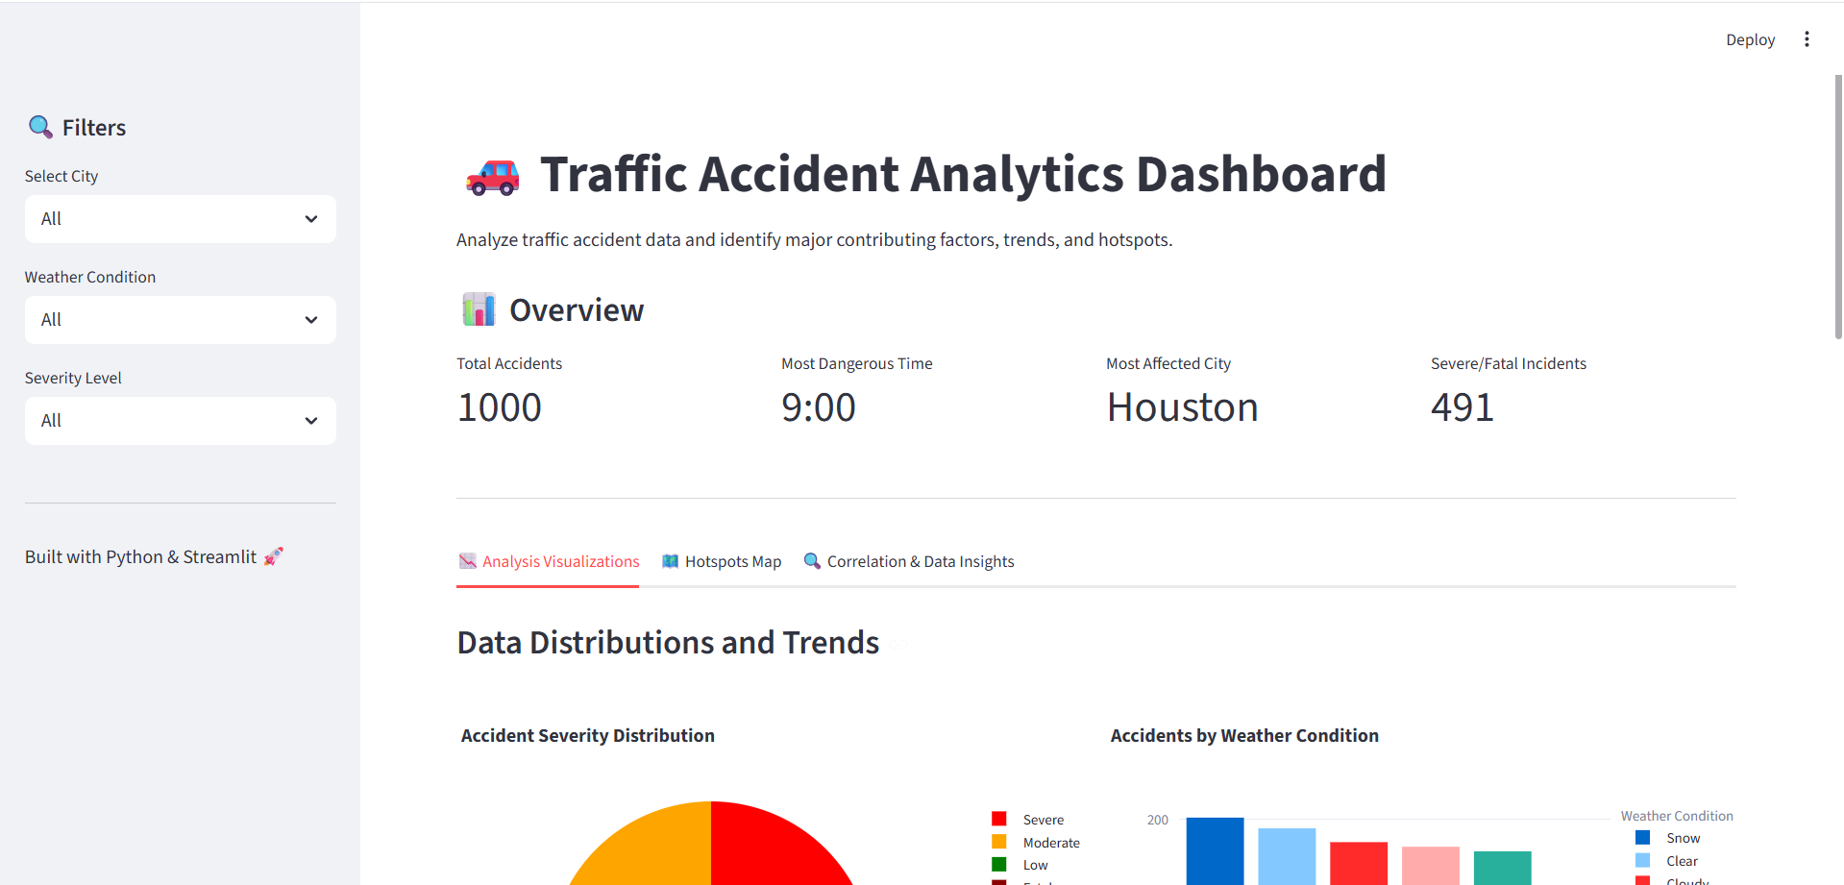

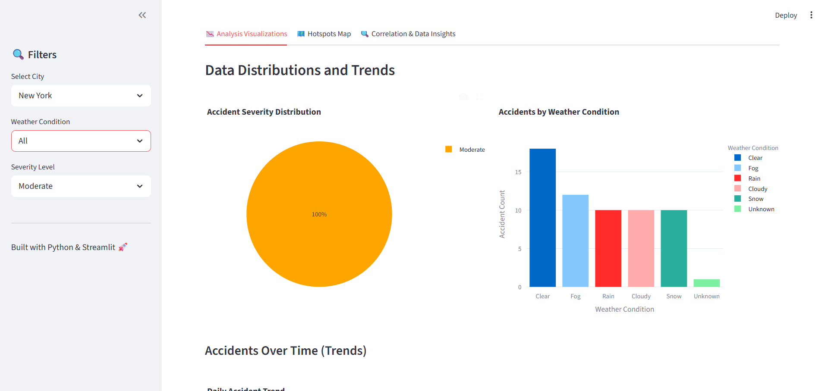

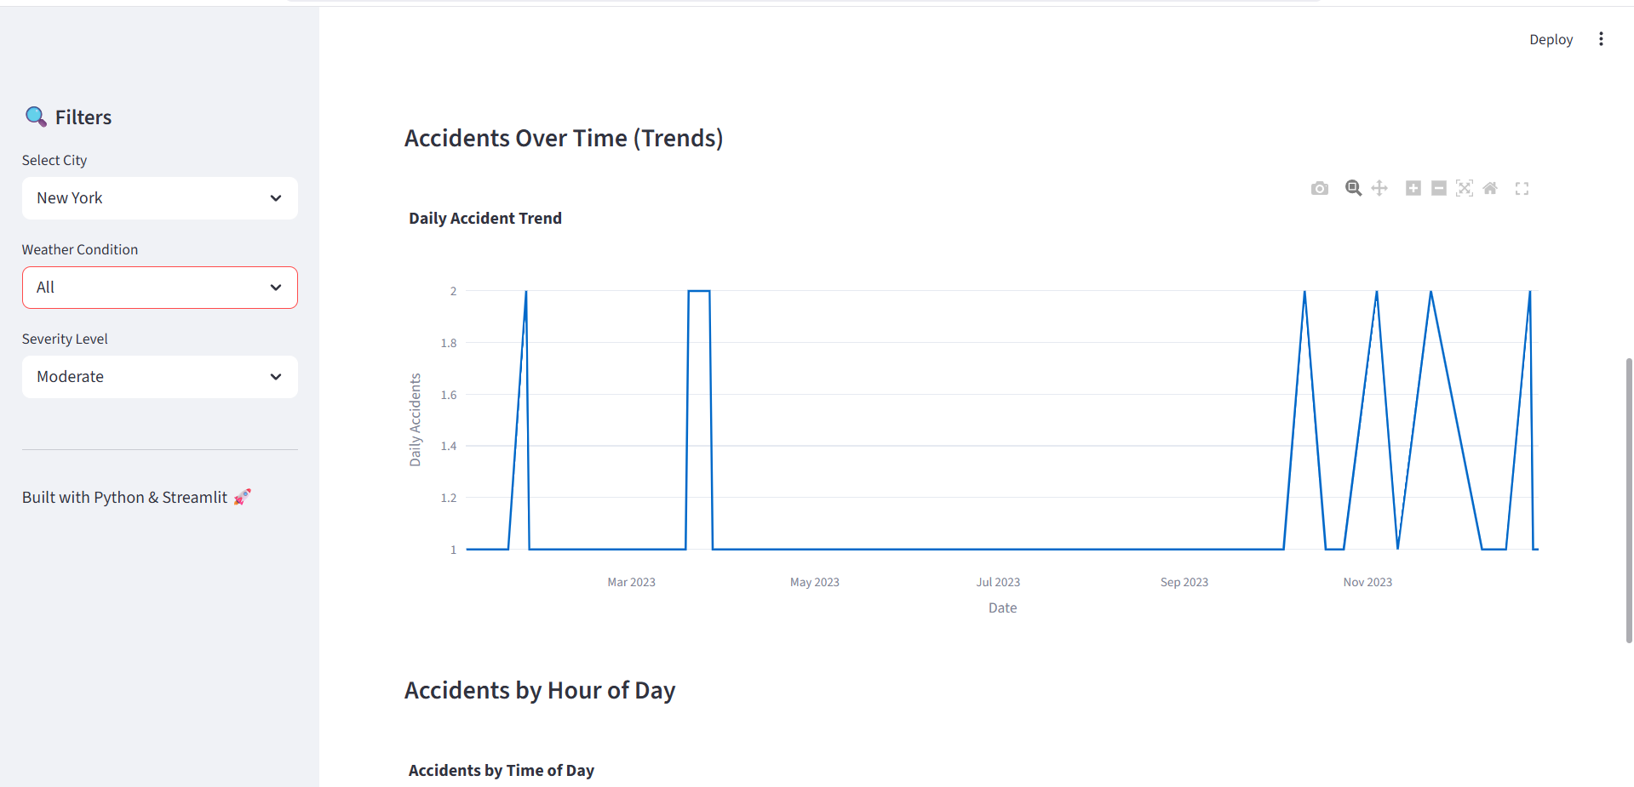

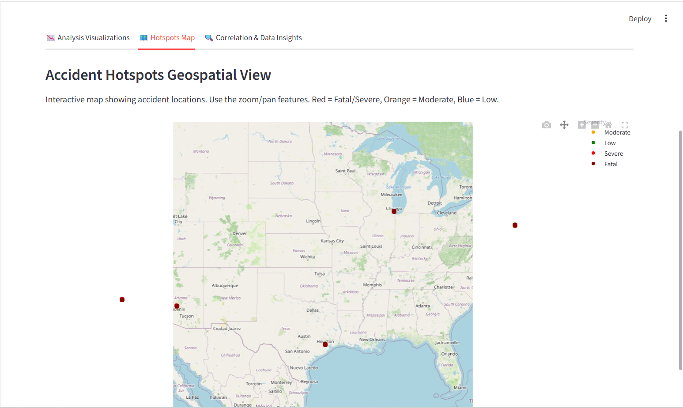

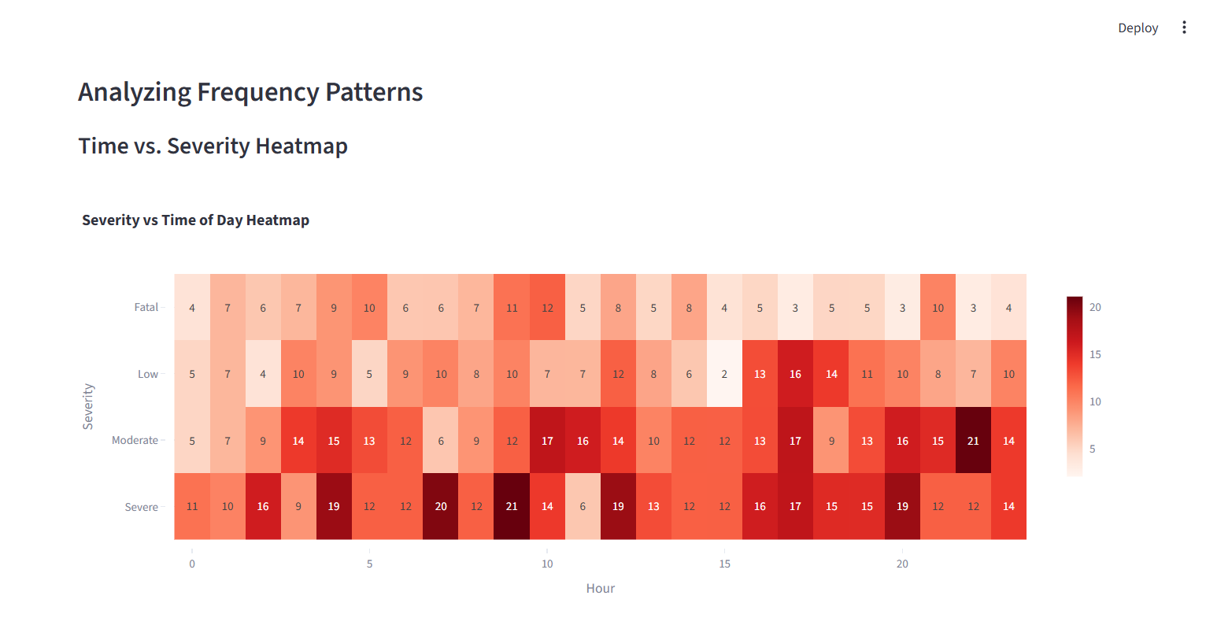
RESULTS AND FUTURE ENHANCEMENT RESULTS
The Traffic Accident Analytics System was successfully developed using Python and Streamlit. The system is capable of processing and analyzing large volumes of accident data efficiently.

The dashboard provides interactive visualizations such as pie charts, bar graphs, line charts, and geospatial maps. These visual tools help in understanding accident patterns clearly and effectively.
From the analysis, it is observed that accident frequency varies based on time, weather conditions, and location. Certain time periods, especially peak traffic hours, show a higher number of accidents.

Weather conditions such as rain and fog also contribute significantly to accident occurrence.
The geospatial visualization highlights accident hotspots by plotting latitude and longitude on a map. This helps in identifying accident-prone areas where safety measures can be implemented.

The system also provides key insights such as the most dangerous time, most affected location, and severity distribution. These insights can assist traffic authorities in taking preventive actions.
Overall, the project demonstrates how data analytics and visualization can be effectively used to improve road safety and support decision-making.

FUTURE ENHANCEMENTS

- The current system provides a strong foundation for traffic accident analysis, but it can be further enhanced with advanced features.

- One major improvement is the integration of real-time traffic data. By connecting with live data sources, the system can provide up-to-date accident analysis and alerts.

- Another enhancement is the use of machine learning models to predict accident probability. Techniques such as classification and regression can be used to forecast high-risk situations based on historical data.
- The system can also be extended to include a mobile application, allowing users to access accident insights on their smartphones. This will improve accessibility and usability.

- Advanced visualization techniques such as 3D maps and interactive dashboards can be implemented for better data representation.

- Integration with GPS and navigation systems can help in providing real-time warnings to drivers about accident-prone areas.

- Additionally, the system can be expanded to include more factors such as traffic density, driver behavior, and vehicle type for more detailed analysis.

Git Hub Link of the project along with  the report | https://github.com/Kavipriyan-p/Customer-Churn-  Prediction.git

REFERENCES:

- Streamlit Official Documentation
https://docs.streamlit.io/
- Pandas Documentation
https://pandas.pydata.org/docs/
- NumPy Documentation
https://numpy.org/doc/
- Plotly Documentation
https://plotly.com/python/
- Python Official Website
https://www.python.org/
- Kaggle Dataset Source
https://www.kaggle.com/datasets

